Exercício form008.html

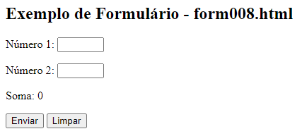

<**form** **action**="**cadastro.php**" **method**="**get**">

<p>

<**label** **for**="**i_numero1**">**Número 1:**</**label**>

<**input** **type**="**number**" **name**="**numero1**" **id**="**i_numero1**"

**min**="**0**" **max**="**50**" **required**

**oninput**="**i_soma.innerHTML** = **Number**(**i_numero1.value**) + **Number**(**i_numero2.value**)">

</p>

<p>

<**label** **for**="**i_numero2"**>**Número 2:**</**label**>

<**input** **type**="**number**" **name**="**numero2**" **id**="**i_numero2**"

**min**="**0**" **max**="**50**" **required**

**oninput**="**i_soma.innerHTML** = **Number**(**i_numero1.value**) + **Number**(**i_numero2**.**value**)">

</p>

<p>

<**label** **for**="**i_soma**">**Soma:**</**label**>

<**output** **name**="**soma**" **id**="**i_soma**">0</**output**>

</p>

<p>

<**input** **type**="**submit**" **value**="**Enviar**">

<**input** **type**="**reset**" **value**="**Limpar**">

</p>  
</**form**>